


Process Design Document

validating applicant information
Process Design Document History

Date | Version | Role | Name | Organization | Function | Comments
24.01.2025 | 1.0 | Draft | Farah Kullab | Voluntra Systems. | SME | Creation v 1.0
24.01.2025 | 1.2 | Reviewer | Vrabie Stefan | UiPath | BA | Approved v 1.0
24.01.2025 | 1.3 | Reviewer | Farah Kullab | UiPath | RPA Dev | Updated

Table of Contents
- Introduction 3
  - Purpose of the document 3
  - Objectives 3
  - Process key contacts 3
- AS IS Process Description 4
  - Process overview 4
  - Detailed Process map 6
  - Detailed Process Steps 8
  - Exceptions handling 11
  - Error mapping and handling 12
  - In-Scope application details 12
- Development details 13
  - Prerequisites for development 13
  - Password policies 13
  - Credentials and asset management 13
- Document Approval Flow 13
- Appendix 14
  - UiPATH automated process details 14

Introduction

  - This project automates the process of extracting application data for events, validating applicant information against predefined criteria, and sending acceptance emails to eligible volunteers. The automation aims to enhance efficiency, reduce manual effort, and ensure accurate communication with applicants.}

The process has been selected for RPA as part of the larger project initiative conducted within Voluntra Systems Inc., the Volunteer Coordination Team
The objective of this process automation is linked to the project business case and is mainly intended to:
  - Deliver faster processing
  - Reduce redundant activities
  - Improve overall performance and reliability


The Design Document includes a brief, but comprehensive set of requirements for the process. Its structure is based on the input provided by the Subject Matter Expert (SME) in the process.

Role | Name | Date of action | Notes
Process SME | Farah Kullab | TBD | Point of contact for questions related to business exceptions and  passwords
Reviewer / Owner | Farah Kullab | TBD | POC for process exceptions
Approval for production | Farah Kullab | TBD | Escalations, Delays

AS IS Process Description
General information about the process selected for RPA implementation, prior to its automation:

AS IS process details
Process full name | Event Application Data Processing Validation
Function | Accepting And rejecting Process
Department | Data Extraction and Validation
Process short description (operation, activity, outcome) | The process automates the extraction of application data for events, validates the applicants' details
Role required for performing the process | System 1 User
Process schedule | Daily
# of item processes / day | 7 – 15 Clients
Average handling time per item | 2 min / Client
Peak period (s) | No peak period
# of FTEs supporting this activity | 1
Level of exception rate | No expected exceptions
Input data | Volunteer Application Data
Output data | Accepted And rejected Data

In scope for RPA
The activities and exceptions in this process that are in the scope for RPA, are listed below:
      - Full Scope for RPA - the process is to be 90% automated.
      - Attended process

Out of scope for RPA
There are no activities out of scope for RPA

This chapter presents the chosen process in detail, which enables the developer to build the automated process.

End

Start
Lunch Voluntra System web application

Login to the web App
Volunteer Application Data Extraction

Navigate the Dashboard
Data Bulk Adding to queue
Get the Transaction Data from orchestrator
Send answering mail for every volunteer with details about event
Check The Requirements for every Volunteer

Step | Short Description
1.1 | Lunch the Voluntra Web Application.
1.2 | Log in to Voluntra Required input data: email and password. ()
1.3 | Access the Dashboard - the central location, where the admin can pick a specific menu item.
1.4 | Access the Application listing to view all the Application to be performed (Output data: Work Items).
1.5 | For each activity of the Application type, perform the following steps:

1.5.A | Meet the requirements from the NGO events excel file to Specify the Accepted volunteers
1.5.B | Check all the match requirements and then write the Accepted and rejected volunteers in the excel file for the NGO
1.5.C | Send the Excel Attachment to the NGO in Email
1.5.D | Send answering email for Accepting or rejecting Volunteers
1.6 | Continue with the next Volunteer Application Activity.


The complete set of steps in the process, including keystrokes and clicks, are to be defined with screenshots. If there are any data restrictions, mask the sensitive information, such as Policy Number, Customer ID, etc).

# | Step action  description | Screenshot | Expected  result | Remarks
1.1 | Open the Voluntra Web Application | 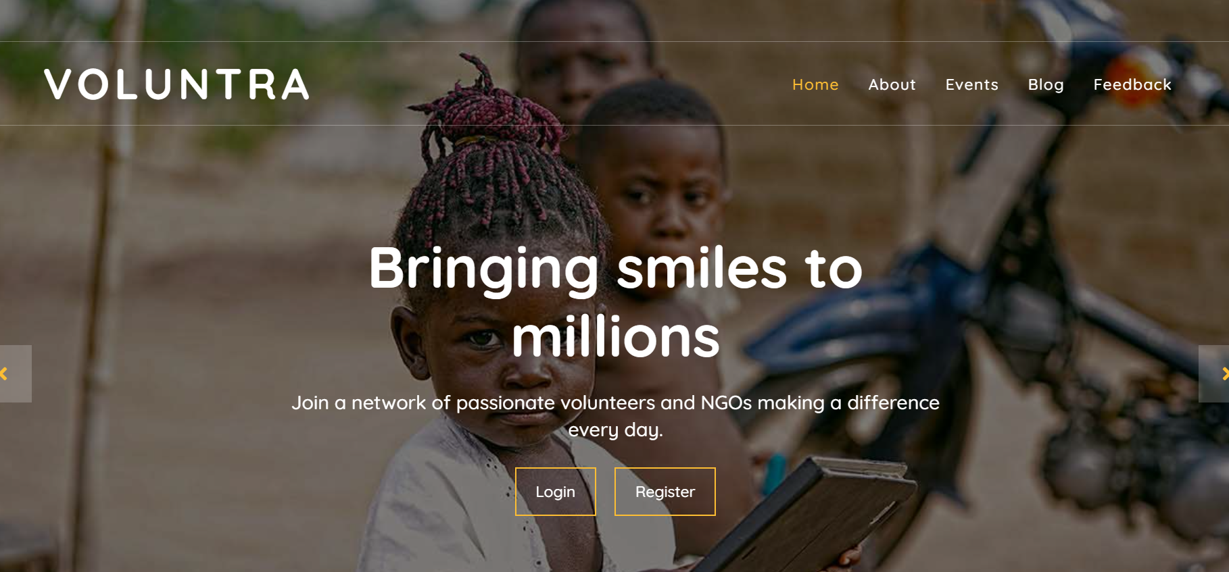 | The display of the System Web App screen. | Possible exception:  - Handle exception if Web app not  available
1.2 | Log in to Web  Required input data: email and password. | 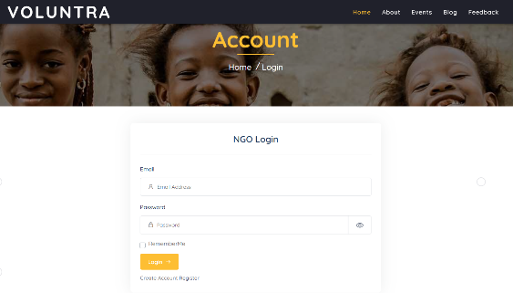 | Access to the dashboard | Possible exception:  - Handle exception if Incorrect email or Password
1.3 | Access the Dashboard - the central location, where the Admin can See all Applications menu. | 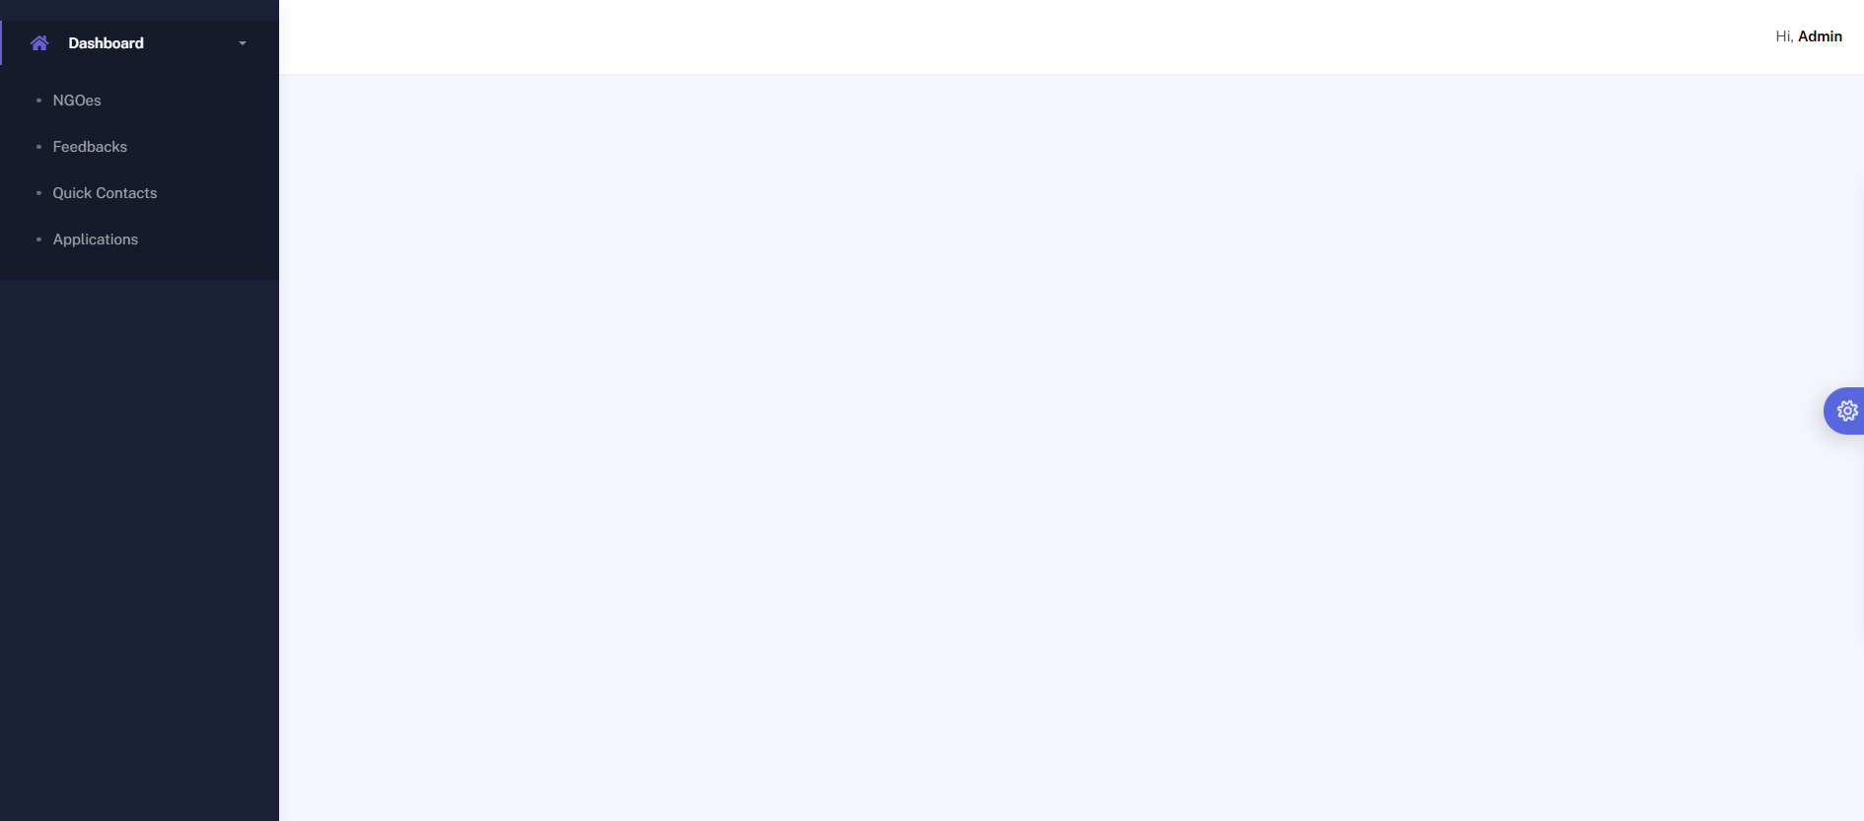 | The display of Application item in the menu

1.4 | Access the Volunteer Applications listing to view all of them. | 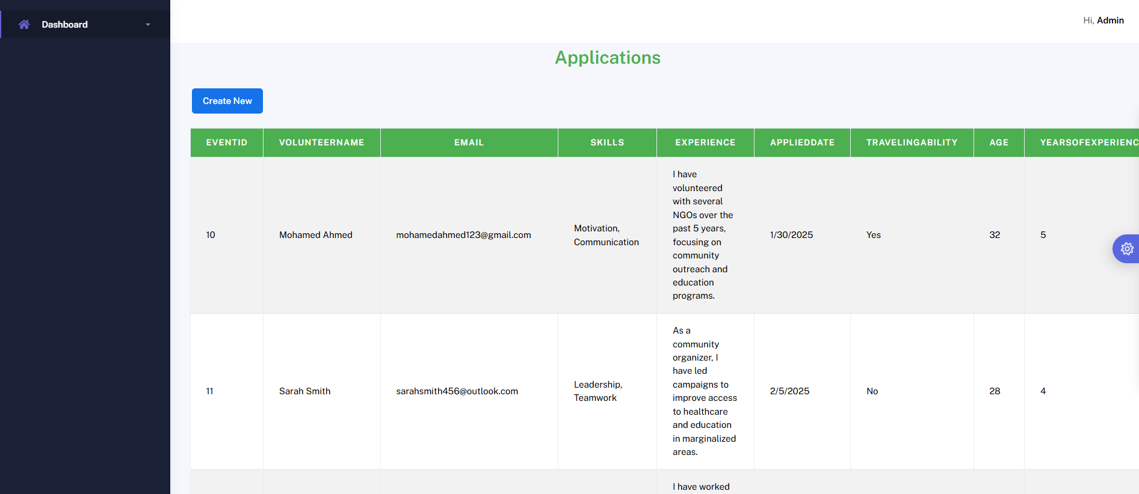 | The display of the task list
1.5 | For each activity of the type Application perform the following steps:
1.5.A | Check all the match requirements  For every Volunteer with the event requirements from the NGOes
1.5.B | Write the Volunteers following Info: [Volunteer name]-  [email]-  [Age] in the NGO Excel sheet and send it as attachment on email to the NGO

1.5.C | Send answering email to Accepted and rejected Volunteers
1.6 | Continue with the  next Volunteer Activity


The types of exceptions identifiable in the automation process can be classified according to the table below.

Area | Known | Unknown
Business | Previously encountered situation. A possible scenario is defined, and clear actions and workarounds are  provided for each case. | A situation never encountered before. It can be caused by external factors.

Based on the above criteria, the table below should reflect all the known exceptions identified throughout the process and map the expected action the robot needs to take in each case.
Insert as many rows as required in the table, to capture all exceptions in a comprehensive list.

# | Exception name | Step where  exception is encountered | Parameters | Action to be taken
1 | Incorrect email or password | Step # 1.2 | If message for incorrect username or password exist | Send email to faraah99kullab@gmail.com  “Hello,  The username or email is incorrect. Please check and restart  Thank you’’

For any other unanticipated or unknown exceptions, the robot should send an email notification at faraah99kullab@gmail.com with the original email and error message screenshot attached.


A comprehensive list of all the errors, warnings, or notifications should be consolidated here with the description and action to be taken by the Robot in each case.
The errors identified in the automation process can be classified according to the table below.

Area | Known | Unknown
Technology | Previously encountered situation  - action plan or workaround available. | A situation never encountered before, or  may happen independent of the applications used in the process.

Based on the above criteria, the table below should reflect all the identifiable errors in the process, and map the expected action of the Robot in each case.
Insert as many rows as required in the table, to capture all the errors in a comprehensive list.

# | Error Name | Step where error is  encountered | Parameters | Action to be taken
1 | Application unresponsive  / page not  loading | Any step | No response / blank page | Retry 2 times.  Close application and run the sequence again
*Feel free to insert an additional error mapping table for more complete explanation.



The table below lists all the applications that are used as part of the automated process.

# | Application name &  Version | Syst. Lang. | Login module | Interface | Environment/ Access method | Comments
1 | Voluntra Web App | EN | Web | Web | Web Browser

Development details

- Development or testing environment are to be provided for development purposes.
- The provided development and testing environments are exact replicas of the production environment.
- Dedicated system and application access are given to developers with the adequate permissions.

Users manage their own passwords. There are no special policies in place.
Login details (user IDs and passwords) should be stored under Windows Credential Manager or
UiPath Orchestrator Assets.

Document Approval Flow
Version | Flow | Role | Name | Organization (Dept.) | Signature and Date:
1.0 | Document prepared by | Business Analyst | Farah Kullab
1.0 | Document Approved by: | Business Process Owner | Farah Kullab
1.0 | Document Approved by: | Dev/RPA Solution Architect | Farah Kullab

Appendix

Note: this step is to be filled in after the automation process is complete Automation overview: (time to dev, test, etc)
Robots type: Attended
Level of human intervention required:
Use of Orchestrator:
Exceptions recorded in automation process:
Errors identified in the automation process:
Challenges identified in the automation process:
Lessons Learned:
Any adjustments made to facilitate the automation process and any steps taken to shift from the human way of working to the automatic one. Any activity performed to improve the As Is process and to enable higher rates of automation of the process:
- Process Assumption
- Input data assumption
- Number or types of input to be received
- Skipping the login interface and collecting backend details
- Extracting backend data without opening the file
- Data conversion / formatting
Reporting: The details and format of the logging mechanism available in the workflow have to be specified here, whether it is a local log report or the Orchestrator log).
The format should be specified by the business users.
Workflow and scripts: A brief overview of each workflow and the sequence in which it is executed should be provided here.

